PO6_Keyboard

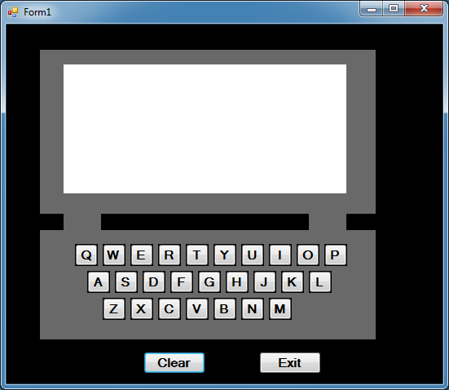

Private Sub btnExit_Click(sender As System.Object, e As System.EventArgs) Handles btnExit.Click

Application.Exit()

End Sub

Private Sub Clear_Click(sender As System.Object, e As System.EventArgs) Handles Clear.Click

lblDisplay.Text = ""

End Sub

Private Sub btnQ_Click(sender As System.Object, e As System.EventArgs) Handles btnQ.Click

lblDisplay.Text = "Q"

End Sub

Private Sub btnW_Click(sender As System.Object, e As System.EventArgs) Handles btnW.Click

lblDisplay.Text = "W"

End Sub

Private Sub btnE_Click(sender As System.Object, e As System.EventArgs) Handles btnE.Click

lblDisplay.Text = "E"

End Sub

Private Sub btnR_Click(sender As System.Object, e As System.EventArgs) Handles btnR.Click

lblDisplay.Text = "R"

End Sub

Private Sub btnT_Click(sender As System.Object, e As System.EventArgs) Handles btnT.Click

lblDisplay.Text = "T"

End Sub

Private Sub btnY_Click(sender As System.Object, e As System.EventArgs) Handles btnY.Click

lblDisplay.Text = "Y"

End Sub

Private Sub btnU_Click(sender As System.Object, e As System.EventArgs) Handles btnU.Click

lblDisplay.Text = "U"

End Sub

Private Sub btnI_Click(sender As System.Object, e As System.EventArgs) Handles btnI.Click

lblDisplay.Text = "I"

End Sub

Private Sub btnO_Click(sender As System.Object, e As System.EventArgs) Handles btnO.Click

lblDisplay.Text = "O"

End Sub

Private Sub btnP_Click(sender As System.Object, e As System.EventArgs) Handles btnP.Click

lblDisplay.Text = "P"

End Sub

Private Sub btnA_Click(sender As System.Object, e As System.EventArgs) Handles btnA.Click

lblDisplay.Text = "A"

End Sub

Private Sub btnS_Click(sender As System.Object, e As System.EventArgs) Handles btnS.Click

lblDisplay.Text = "S"

End Sub

Private Sub btnD_Click(sender As System.Object, e As System.EventArgs) Handles btnD.Click

lblDisplay.Text = "D"

End Sub

Private Sub btnF_Click(sender As System.Object, e As System.EventArgs) Handles btnF.Click

lblDisplay.Text = "F"

End Sub

Private Sub btnG_Click(sender As System.Object, e As System.EventArgs) Handles btnG.Click

lblDisplay.Text = "G"

End Sub

Private Sub btnH_Click(sender As System.Object, e As System.EventArgs) Handles btnH.Click

lblDisplay.Text = "H"

End Sub

Private Sub btnJ_Click(sender As System.Object, e As System.EventArgs) Handles btnJ.Click

lblDisplay.Text = "J"

End Sub

Private Sub btnK_Click(sender As System.Object, e As System.EventArgs) Handles btnK.Click

lblDisplay.Text = "K"

End Sub

Private Sub btnL_Click(sender As System.Object, e As System.EventArgs) Handles btnL.Click

lblDisplay.Text = "L"

End Sub

Private Sub btnZ_Click(sender As System.Object, e As System.EventArgs) Handles btnZ.Click

lblDisplay.Text = "Z"

End Sub

Private Sub btnX_Click(sender As System.Object, e As System.EventArgs) Handles btnX.Click

lblDisplay.Text = "X"

End Sub

Private Sub btnC_Click(sender As System.Object, e As System.EventArgs) Handles btnC.Click

lblDisplay.Text = "C"

End Sub

Private Sub btnV_Click(sender As System.Object, e As System.EventArgs) Handles btnV.Click

lblDisplay.Text = "V"

End Sub

Private Sub btnB_Click(sender As System.Object, e As System.EventArgs) Handles btnB.Click

lblDisplay.Text = "B"

End Sub

Private Sub btnN_Click(sender As System.Object, e As System.EventArgs) Handles btnN.Click

lblDisplay.Text = "N"

End Sub

Private Sub btnM_Click(sender As System.Object, e As System.EventArgs) Handles btnM.Click

lblDisplay.Text = "M"

End Sub

End Class